What is an LLM?
Large Language Model
Examples:
ChatGPT
Claude
Gemini
Llama
Why LangChain?
Problems with using LLMs directly:
No memory
Cannot access documents
Cannot call APIs
Cannot perform multi-step reasoning
LangChain solves these problems by providing:
Prompt management
Memory
Chains
Agents
Retrieval
Tool calling

Langchain:
The perpose of creating langchain is to simply the process of creating generative AI application.
*Langchain is an open source framework for developing applications powered by language models.
The word langchain is merged word of lang and chain
*lang: It is the short form of the term Language.
*Chain: It emphasizes the connection of various elements to create advanced applications around LLMs.
* Opensource development framework for LLM applications.
* python and javascript (type script) packages
* Focused on composition and madularity

What is a Prompt?
A prompt is the instruction given to an LLM to generate a response.
Example:
- Explain Python.
- You are a Python trainer. Explain Python for beginners.
How to create a prompt:
Task (1.Persona- for whom we need to create audience or manager..etc
Format- referes how to want output it may list, table)
2. Context (it’s understand what you need from it)
3. References (adding some examples )
4. Evaluate ( based on input providing output)
5. Iterate (if you are not getting expected output you can try again more information)
(Thoughtfully create Really Excellent Inputs)
2. Why Prompt Management?
Problems without prompt management:
- Hardcoded prompts
- Difficult to maintain
- Difficult to reuse
- Difficult to update
LangChain solves this using Prompt Templates.
3. Prompt Template
Example:
from langchain.prompts import PromptTemplate
prompt = PromptTemplate(
input_variables=["topic"],
template="Explain {topic} in simple terms"
)
Benefits:
- Reusability
- Dynamic Input
- Better maintenance
4. Types of Prompt Templates
A. Simple Prompt Template
Ex:
from langchain.prompts import PromptTemplate

prompt = PromptTemplate(
template="What is {topic}?",
input_variables=["topic"]
)
B. Chat Prompt Template
System Message Human Message AI Message
from langchain.prompts import ChatPromptTemplate

prompt = ChatPromptTemplate.from_messages([
("system", "You are a helpful teacher."),
("human", "{question}")
])
5. System Message
Defines AI behavior.
Examples:
- You are a medical expert.
- You are an HR interviewer.
- You are a Python trainer.
6. Human Message
Represents the user's question.
Examples:
- What is diabetes?
- Explain Python OOPs.
7. AI Message
Represents previous AI responses and helps maintain conversation context.
C. Prompt Techniques
Few-Shot Prompting
Role-Based Prompting
Prompt Chaining
8. Few-Shot Prompting
Provide examples before asking the actual question.
Helps the model learn the expected response format.
9. Role-Based Prompting
Examples:
- You are a senior HR interviewer. Ask 5 technical Python interview questions.
- You are a medical specialist. Generate diagnosis suggestions.
10. Prompt Chaining
Output of one prompt becomes input to another.
Example Workflow:
Resume
-> Extract Skills
-> Generate Questions
-> Evaluate Answers

Memory Types
ConversationBufferMemory
This memory allows for storing of messages and then extracts the messages in a variable.
Ex: A customer support chatbot for an e-commerce website.
ConversationBufferWindowMemory
This memory keeps a list of the interactions of the conversation over time. It only uses the last K interactions.
Ex: A medical assistant chatbot that only remembers last K interactions
ConversationTokenBufferMemory
This memory keeps a buffer of recent interactions in memory, and uses token length rather than number of interactions to determine when to flush interactions.
Ex:store in form of tokens. If tokens are fulled the old data will be removed
ConversationSummaryMemory
This memory creates a summary of the conversation over time
Ex:meetings
Additional Memory Types
Vector data memory
Stores text (from conversation or elsewhere) in a vector database and retrieves the most relevant blocks of text.
Entity memories
Using an LLM, it remembers details about specific entities.
You can also use multiple memories at one time.
E.g., Conversation memory + Entity memory to recall individuals.
You can also store the conversation in a conventional database (such as key-value store or SQL).
Sequential Chains
Sequential chain is another type of chains.
The idea is to combine multiple chains where the output of the one chain is the input of the next chain.
There is three type of sequential chains:
SimpleSequentialChain: Single input/output
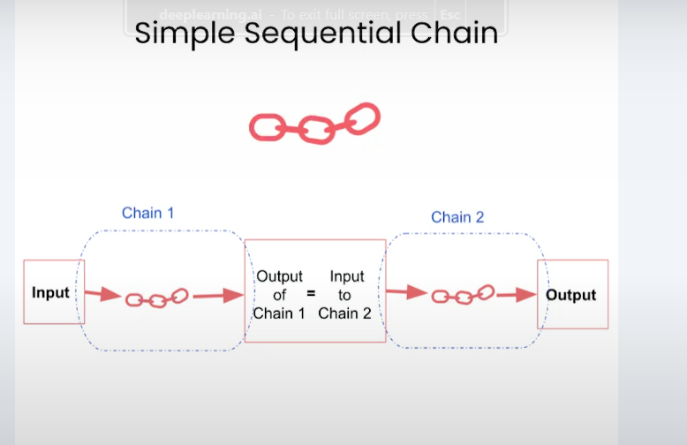
Ex:
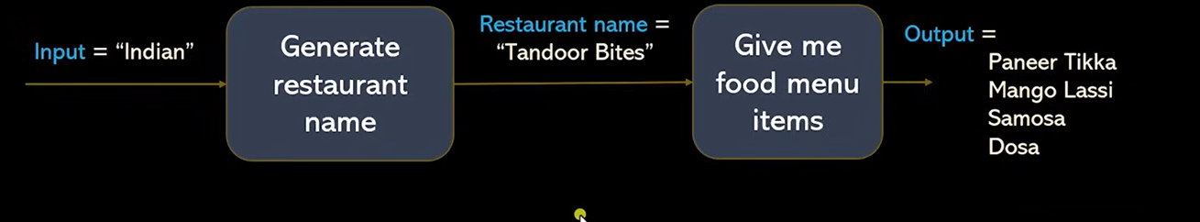
It runs one step, then passes the result to the next step automatically. Only one input and one output.
🎯 Real Example: Product → Slogan → Social Media Post
Let's say you're launching a product like “Smart Water Bottle”.
🔗 Step 1:
Make a slogan for the product
Input: Smart Water Bottle
Output: "Hydrate Smarter, Live Better"
🔗 Step 2:
Create a social media post using that slogan
Input: "Hydrate Smarter, Live Better"
Output:
"Introducing our new Smart Water Bottle! Hydrate Smarter, Live Better. Stay healthy, stay cool!"
It goes like:
text
CopyEdit
User → [Slogan Generator] → [Social Media Post Generator] → Final Output

SequentialChain: Multiple inputs/outputs
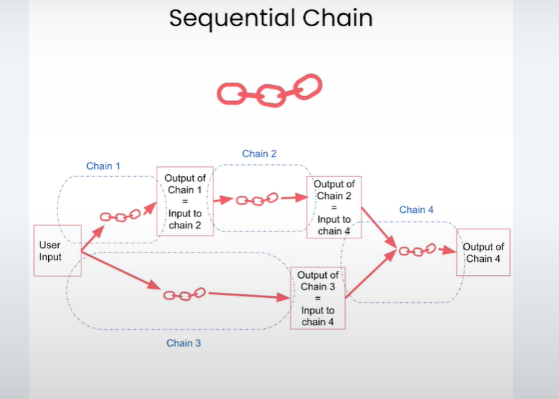
Ex:
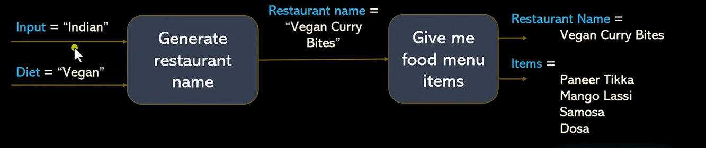

You give multiple inputs and can get multiple outputs. You have more control over what data moves between steps.
🎯 Real Example: Medical Resume → Skills, Experience → Questions
Let’s say you upload a medical resume:
🔗 Step 1: Extract skills
🧾 Input: Resume
🧠 Output: “Cardiology, Patient Care, ECG”
🔗 Step 2: Estimate experience
🧾 Input: Resume
🧠 Output: “5 years”
🔗 Step 3: Generate questions
🧾 Input: Skills + Experience
🧠 Output:
“Describe how you would handle a heart attack emergency in an ICU.”
“How do you monitor post-ECG results in elderly patients?”
🔁 This lets you use multiple variables between steps:
EX:
User → [Skills Extractor] + [Experience Estimator] → [Question Generator] → Final Questions

3.Router Chain(Smart branching):
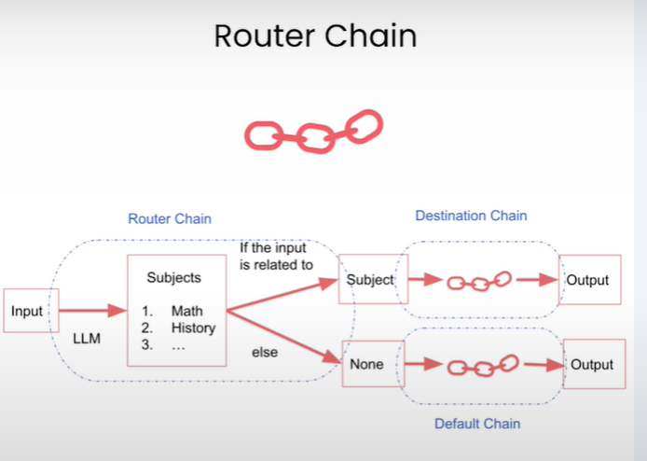
Routes the input to different chains depending on the content. Like if/else logic.
🎯 Real Example: AI Support Assistant
Let’s say a user types:
“Where is my order?” → Route to Order Chain
“Why is my bill double?” → Route to Billing Chain
“My app is crashing!” → Route to Tech Support Chain
EX:
User → [Router Chain] → sends to correct Chain → Final Answer
So the RouterChain acts like a smart switchboard:
go
CopyEdit
If input talks about:
📦 "order" → go to order_chain
🛠️ "not working", "crash" → go to tech_support_chain
💳 "charged", "bill" → go to billing_chain

Note:
Retrieval and Document Chains, explain:
PDF
DOCX
TXT
CSV
↓
Document Loader
↓
LangChain Documents
Examples:
LangChain community packages:
PyPDFLoader
TextLoader
CSVLoader
DirectoryLoader
Why?
Candidates will ask:
How does LangChain read a PDF?
Answer:
Using Document Loaders.

2. Text Splitters (Must Add)
After Document Loaders:
Large PDF
↓
Text Splitter
↓
Chunks
Example:
RecursiveCharacterTextSplitter
Explain:
Chunk Size
Chunk Overlap
Why?
Without chunking:
500-page PDF
won't fit into the LLM context window.

3. Embeddings & Vector Database (Must Add)
Before Retrieval:
Document
↓
Embedding Model
↓
Vectors
↓
Vector Database
Examples:
Sentence Transformers
HuggingFace Embeddings
Vector DBs:
FAISS
Chroma
Simple explanation:
Text
↓
Numbers (Vectors)
↓
Similarity Search
Why?x
Retrieval cannot work without embeddings and vector storage

Document Chains
Document Chains are techniques used to process external documents before sending information to the LLM
Stuff- Method:
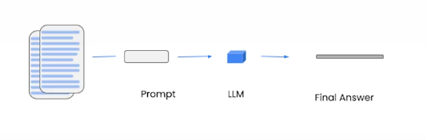
put all the data (documents, text, notes, etc.) directly into one big prompt and send it to the LLM in a single call.
You’re "stuffing" all your context into one prompt so the model can "see" everything at once
1.Map_reduce:
• Map Step: Break the document into small chunks.
• Each chunk is summarized or processed separately.
• Reduce Step: Combine all those outputs into one final result.
EX: • Teacher checks each student’s paper separately (map).
• Then combines scores to make the class average (reduce).
• Why it sticks: Process separately → combine results.
• In LLM: Summarize each document → merge summaries

2.Refine-method:
Process the first chunk and generate an initial answer
Then go chunk-by-chunk, refining or improving the answer with each step
EX:
Start cooking curry with basic ingredients.
Keep tasting and adding spices until perfect.
Why it sticks: Step-by-step improvement with new info.
In LLM: Initial answer from first doc → refine with each next doc.

.
3.Map-rerank:
• Process each chunk independently for relevance or usefulness
• Score each answer (e.g., based on accuracy or relevance)
• Choose the best one
EX:
Taste each mango and give it a score (map).
Keep only the sweetest ones (rerank).
• Why it sticks: Evaluate all, keep top ones.
• In LLM: Score documents for relevance → pick best.

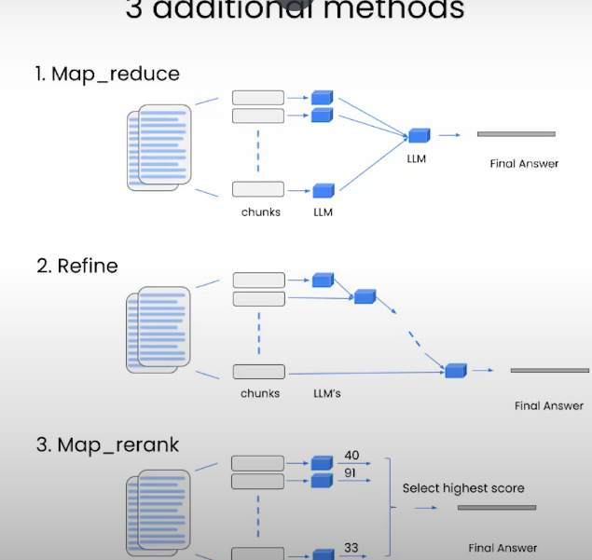

Retrieval
What Problem Does It Solve?
LLMs don't know your private documents.
Example:
User:
What is the leave policy in my company?
LLM:
I don't know.
Because the leave policy exists in a PDF.
Retrieval Solution
Search the document first.
PDF
│
▼
Search Relevant Content
│
▼
Send to LLM
│
▼
Answer
Flow
User Question
│
▼
Retriever
│
▼
Relevant Chunks
│
▼
LLM
│
▼
Answer
Tool Calling
What Problem Does It Solve?
LLMs cannot directly:
Calculate accurately
Access APIs
Access databases
Search the web
Tool Calling Solution
Give the LLM access to external functions.
Example Tools
Weather Tool
Calculator Tool
Database Tool
Search Tool
Flow
User Question
│
▼
LLM
│
▼
Calls Tool
│
▼
Gets Result
│
▼
Returns Answer
Real Example
User:
What is 5678 × 9876?
LLM:
Uses Calculator Tool
Calculator:
56073528
LLM:
Returns answer
One-Line Definition
Tool Calling = Allowing the LLM to use external functions, APIs, or services to perform tasks.
Agents
What Problem Does It Solve?
Normally, an LLM only answers based on its knowledge.
Example:
User: What's the weather in Bangalore today?
LLM:
I don't know current weather.
Agent Solution
An Agent can decide:
1. What does the user need?
2. Which tool should I use?
3. Get the result
4. Return the answer
Flow
User Question
│
▼
Agent
│
▼
Select Tool
│
▼
Get Result
│
▼
Return Answer
Real Example
User:
What's the weather in Bangalore?
Agent:
Need Weather API
Weather Tool:
32°C
Agent:
Returns answer to user
One-Line Definition
Agent = An AI decision-maker that chooses which tool to use and when to use it.
Ex:
Teach these 4 projects:
PDF Question Answering Bot → Retrieval
Resume Analyzer → Chains
Customer Support Chatbot → Memory
Weather Assistant → Tool Calling + Agents

Memory in AI Agents (LangChain)
Overview
Memory is a system that allows AI agents to remember information from previous interactions. It is crucial because it enables agents to:
Types of Memory
1️Short-Term Memory
Purpose: Remembers interactions within a single conversation or session.
Use case: Chatbots that need context only while the user is actively talking.
Example: If the user says, “My name is Alice,” the agent can later respond, “Nice to meet you, Alice,” during the same conversation.
LangChain Examples:
ConversationBufferMemory → stores full conversation
ConversationBufferWindowMemory → stores only the last N messages
2 Long-Term Memory
Purpose: Remembers information across multiple sessions.
Use case: Personalized assistants that recall user preferences over time.
Example: The agent remembers that Alice prefers tea over coffee even if she returns tomorrow.
LangChain Examples:
Vector/embedding-based memory (stores conversation in a vector database for semantic retrieval)
Key-value memory (stores facts or entities persistently)

